Lighting Lecture Notes
Pawn
3 point lighting
Key
Generally shadow casting light
Main light source
Fill
Fill in shadows
Compliment of key usually (color)
Lower intensity than key
Rim
Generally higher or equal to key intensity
Shadows, depth map

Lighting the pawn
Key
NAME
Place the light at position (x, y, z) = (13, 27, 21).
The key light is generally placed above the subject and a bit to the left or right of the camera.
Use the t key to show the light's target. Place the target inside the pawn.
In the Attribute Editor, change the Intensity of the light to 1.5 and the color (H, S, V) to (60, 0.134, 1).
Render
Set the Cone Angle to 20, the Penumbra Angle to 25, and the Dropoff to 0.25. This will give a nice, soft edge to the Spotlight.
Render
Enable Depth Map Shadows in the Attribute Editor and set the Resolution to 1024and the Filter Size to 8.
Fill
Place it at (x, y, z) = (-19, 17, 20).
With the light selected, use Panels → Look Through Selected Camera to point the light at the pawn.
Set the Intensity to 1.25, the Cone Angle to 20, the Penumbra Angle to 70, the Dropoff to1.25,
and the Color (H, S, V) to (240, 0.388, 0.721).
Uncheck the Emit Specular box so that only the key light casts specular highlights on the front of the pawn.

Rim
Place the rim light at the position (x, y, z) = (-4, 14, -25)
Set the Intensity to 1.8 and the Color (H, S, V) to(60, 0.366, 1).
Notice that he rim casts a rather harsh cone of light on the ground.
Select the rim light and the background and go to Lighting/Shading → Break Light Links.
Light linking editor
Light visibility
Deleting lights (problem)
Room Lighting
Using mental ray and rey trace shadows
Assignment: pick a room
Replicate it to the best of your ability
Take questions,
Demonstrate in pawn maya software and raytracing and metnal rey differences
SHADOW PROBLEMS

Types of lights in maya
Spot light
Cone
Area light
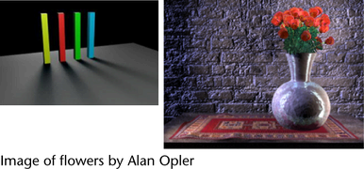
In Maya, area lights are two-dimensional rectangular light sources. Use area lights to simulate the rectangular reflections of windows on surfaces. An area light is initially two units long and one unit wide. Use Maya’s transformation tools to resize and place area lights in the scene.
Compared to other light sources, area lights can take longer to render, but they can produce higher quality light and shadows. Area lights are particularly good for high-quality still images, but less advantageous for longer animations where rendering speed is crucial.
Area lights are physically based—there is no need for a decay option. The angles formed with the area light and the point that is shaded determine the illumination. As the point moves further away from the area light, the angle decreases and illumination decreases, much like decay.

Volume light
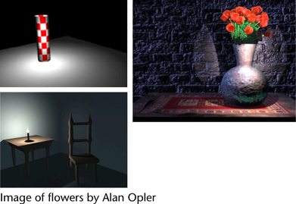
A major advantage of using a volume light is that you have a visual representation of the extent of the light (the space within which it is bound).

The falloff of light in the volume can be represented by the color ramp (gradient) attribute in Maya, which prevents the need for various decay parameters, and also provides additional control. The color gradient is also useful for volume fog.

Directional light
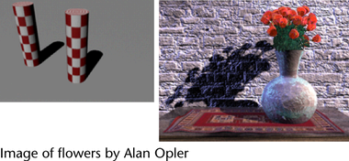
Use a directional light to simulate a very distant point light source (for example, the sun as viewed from the surface of the Earth).
A directional light shines evenly in one direction only. Its light rays are parallel to each other, as if emitted perpendicular from an infinitely large plane.

Ambient Light
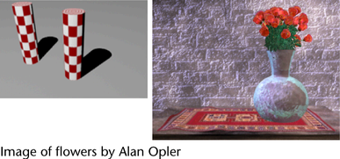
A Maya ambient light shines in two ways—some of the light shines evenly in all directions from the location of the light (similar to a point light), and some of the light shines evenly in all directions from all directions (as if emitted from the inner surface of an infinitely large sphere).
Use an ambient light to simulate a combination of direct light (for example, a lamp) and indirect light (lamp light reflected off the walls of a room).

Point Light
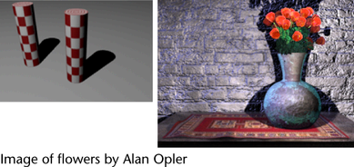
A point light shines evenly in all directions from an infinitely small point in space. Use a point light to simulate an incandescent light bulb or a star.

